TEORÍA DE AUTÓMATAS Y LENGUAJES FORMALES
CURSO 2021

Práctica 1:
1)Design in JFLAP a FA that accepts any binary numbre which has even numbers of 0’s and 1’s
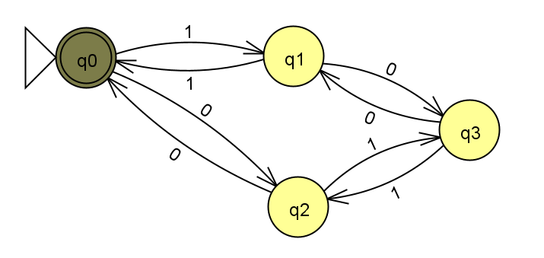

2) Design in JFLAP a FA that accepts any binary number, which is divisible by 13. The input is a binary string, starting with the most significant bit. The input size is unlimited, and it can start with one or more 0's.

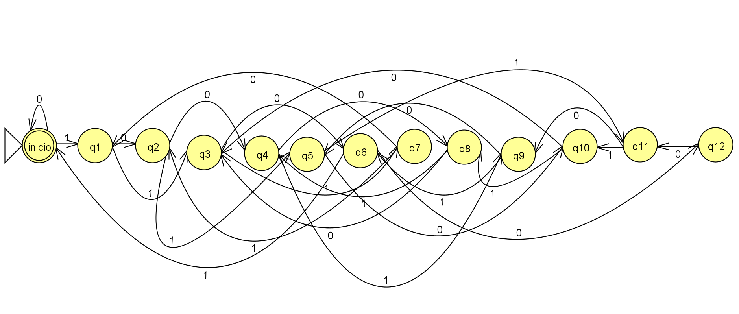

Práctica 2:
Design a minimum DFA that accepts the languaje composed of strings representing numbers in scientificnotation, following the format:
{+,-,epsilon} digit ',' digits 'E' {+,-,epsilon} digits
where:
digit ∈ {0, 1, ..., 9}
digits ∈ {0, 1, ..., 9}⁺
It is not allowed a '+' or '-' symbol before 0,0. Also, the exponent must be 0 if the significand is 0,0.
For instance, the following strings should be incorrect:
+0,0E0
0,23E-0
0,0E124
0,25E
3,E4
3,0E-
The following strings would be correct:
0,0E0
0,000E0000
+0,23E0
-1,8E+34
1,007E3
+5,42E-3
Design the DFA and implement it in JFLAP and test it with a representative set of correct and incorrect input strings. Submit both the JFLAP file and the text file with all tested input strings.
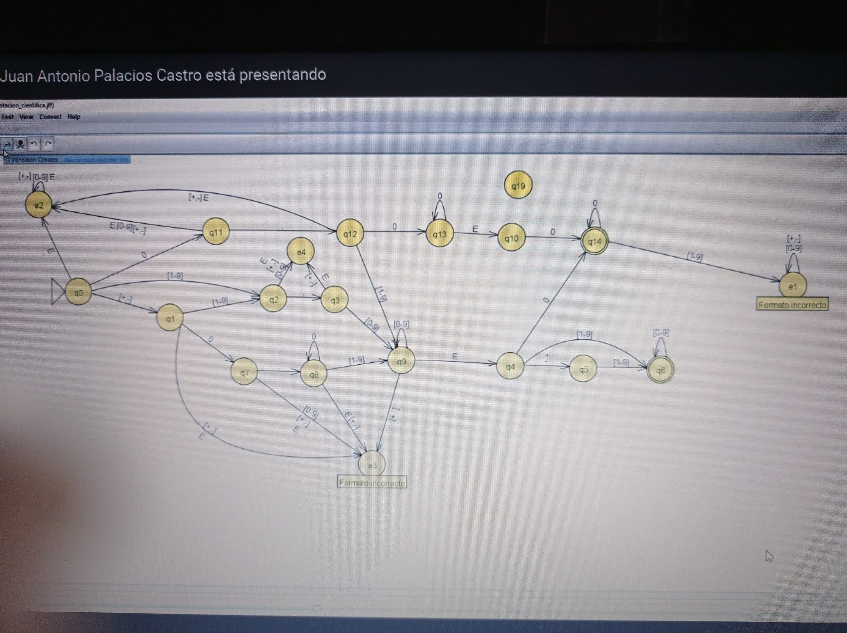

Práctica 3
Design a NFA to accept words composed by the letters in "HIDALGO", in any order, with a maximum of: two A's, one D, and one L. It can have any number of H's, I's, G's and, O's.
Examples of correct strings:
HALA - HALO - HADA - LIADA - GALGO - LADO - HALAGO
Examples of incorrect strings:
HALLA - DADO - ALADA - HALAGA - LOLA

